

**REVISED UNIVERSAL SOIL LOSS**

**EQUATION 2 (RUSLE2)**

**Visit our Website at** [**http://ratools.msstate.edu**](http://ratools.msstate.edu)

**Get the RUSLE2 APP at http://ratools.msstate.edu/apps/rusle2/**

**RUSLE2** is an erosion prediction tool that is intended for all conservation planning, inventory erosion rates and estimate sediment delivery, this tool is a modified version of the RUSLE and USLE tool. RUSLE2 was developed jointly by the USDA-Agricultural Research Service (ARS), the USDA-Natural Resources Conservation Service (NRCS), and the University of Tennessee.

**T**he Revised Universal Soil Loss Equation 2 (RUSLE2) estimates soil loss from rill and interrill erosion caused by rainfall on cropland. In other words, RUSLE2 is an advanced, user-friendly software model that predicts long-term, average-annual erosion by water. It runs in a Windows environment, and can be used for a several alternative combinations of crop system and management practice. It also considers specified soil types, rainfall patterns, and topography. When these predicted losses are compared with soil loss tolerances, RUSLE2 provides specific guidelines for effective erosion control.

0

In addition to sheet and rill erosion losses, the RUSLE2 program estimates:

1. Soil Conditioning Index (SCI)
2. Soil Tillage Intensity Rating (STIR)
3. Soil Loss, and
4. Fuel Costs.

These outputs are used together as a tool to evaluate the impact of existing farming operations on soil loss and soil organic carbon. _e output values also can be useful in helping decide which conservation practice(s) will provide the most benefit for reducing soil losses and increasing soil carbon.

**R**USLE2 computes values for the three fundamental erosion processes of detachment (sediment production), transport, and deposition. The empirical equation form of the USLE is used to compute detachment while process-based equations are used to compute sediment transport and deposition. These equations, which are written for a point in time and a location on an overland flow path, are integrated in both time and distance to produce average annual and spatial estimates for segments along the overland flow path and for the entire overland flow path.

**How does RUSLE2 works?**

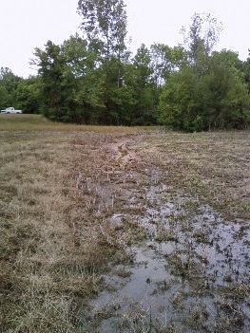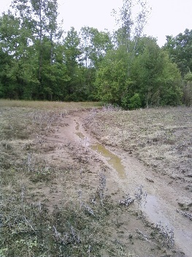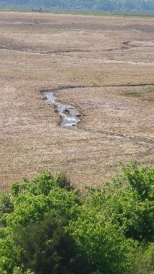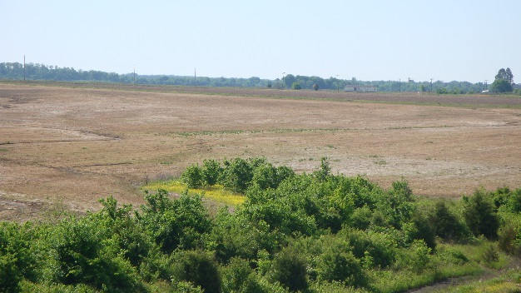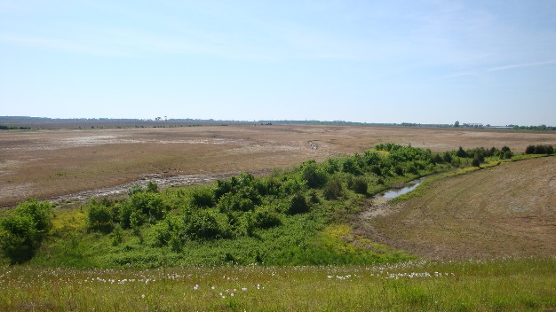

1 Rill and interrill erosion is the removal of layers from the land surface by the action of rainfall and runoff. Erosion begins with the impact of raindrops, detaching soil particles and moving them across the surface. This process causes interrill erosion (sometimes called sheet erosion). Runoff from interrill erosion will collect and form rills across the hill slope. Sediment from rill and interrill erosion is transported down slope to where it slows enough to be deposited on the land surface or deposited directly into concentrated flow channels.

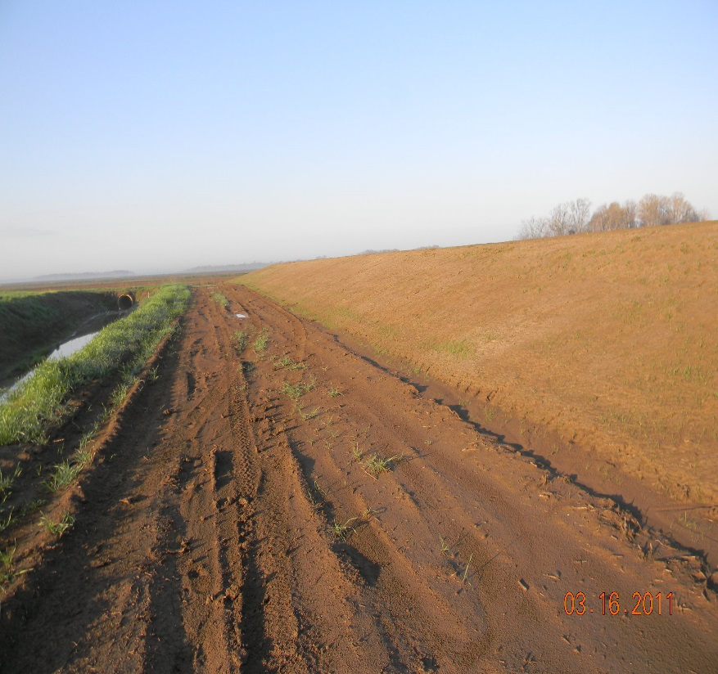

**Understanding the Components**

**Included in RUSLE2**

**References:**

USDA- Agricultural Research service. 2013. Revised Universal Soil Loss Equation Version 2 (RUSLE2) (For the model with release data of May20, 2008). August 2013. Available online at: <http://www.ars.usda.gov/sp2UserFiles/Place/64080510/RUSLE/RUSLE2_Science_Doc.pdf>.

USDA-ARS. 2004. User’s Reference Guide. Revised Universal Soil Loss Equation Version 2. Available online at: <http://fargo.nserl.purdue.edu/rusle2_dataweb/userguide/RUSLE2-2-3-03.pdf>.

**For more Information Contact Us:**

**Dr. John Ramirez-Avila**

Email: [jjr149@cee.msstate.edu](mailto:jjr149@cee.msstate.edu)   
Phone: (662) 325-9885

**Dr. J. Larry Oldham**

Email: [loldham@pss.msstate.edu](mailto:loldham@pss.msstate.edu)

Phone: (662) 325-2760

v

**Slope steepness – S.** The slope steepness factor (S) reflects the influence of slope gradient on erosion. Slope is estimated in the field by use of an inclinometer, Abney level, or similar device.

**Cover Managements – C.** The cover-management factor “c” represents how soil (other than that represented by the unit plot condition), vegetation, and residue (material on and in the soil) affect soil loss.

**Support Practices – P.** The supporting practice P factor describes the effects of practices such as contouring, strip cropping, concave slopes, terraces, sediment basins, grass hedges, silt fences, straw bales, and subsurface drainage.

**Climate Erodibility – R.** The climate erodibility is an index of the erosivity at an allocation, which is related to rainfall amount (how much it rains) and intensity (how hard it rains).

**Soils erodibility measured under a standard condition – K.** The soil-erodibility factor (K) represents: (a) the susceptibility of soil or surface material to erosion, (b) the transportability of the sediment, and (c) the amount and rate of runoff given a particular rainfall input, as measured under a standard condition.

**Slope length – L.** The slope length term is used to compute detachment for a segment where detachment is a function of the position of the segment along the hillslope profile.

4. Mississippi Soil Test Method P

5. Inorganic P2O5 Rate Applied

6. Inorganic P2O5 Application Method

7. Organic P2O5 Rate Applied

8. Organic P2O5 Application Method.

**Source**

**Characteristics**